Chapter 16, Problem 28.

For the circuit in Fig. 16.51, find v(t) for t > 0.
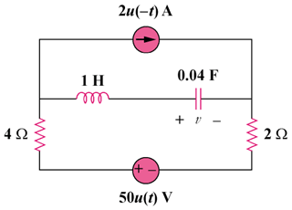
4u(–t) A
100u(t) V

Figure 16.51
For Prob. 16.28.

Solution

Step 1. Determine the initial conditions (at t = 0, the 4 amp current source turns off and the 100 volt voltage source becomes active). Since the capacitor becomes an open circuit, i_{L}(0) = 0 and v(0) = –4x6 = –24 volts. Now convert the circuit into the s-domain and solve for V and then convert it into the time domain to obtain v(t),
+ −

100/s

25/s

s

4

2
− +

24/s
+ −

V

I

Now for the mesh equation, [4+s+(25/s)+2]I–(24/s)–(100/s) = 0. V = (25/s)I–24/s.

Step 2. [(s²+6s+25)/s]I = 124/s or I = 124/(s²+6s+25) = 124/[(s+3+j4)(s+3–j4)] thus,

V = {3100/[s(s+3+j4)(s+3–j4)]}–24/s = [A/s]+[B/(s+3+j4)]+[C/(s+3–j4)] where
A = (3100/25)–24 = 124–24 = 100; B = 3100/[(–3–j4)(–j8)]
= 3100/[(5∠–126.87˚)(8∠–90˚)] = 77.5∠–143.13˚; and
C = 3100/[(j8)(–3+j4)] = 3100/[(5∠126.87˚)(8∠90˚)] = 77.5∠143.13˚.

v(t) = [100+155e^{–3t}cos(4t+143.13˚)]u(t) volts.

